Annexure 3b- Complete filing

INVENTION DISCLOSURE FORM

Details of Invention for better understanding:

- TITLE: PORTABLE ECG AND HEART RATE LOGGER
2. INTERNAL INVENTOR(S)/ STUDENT(S): All fields in this column are mandatory to be filled
A. Full name | Hita Khera
Mobile Number | +91 88472 20038
Email (personal) | hitakhera@gmail.com
UID/Registration number | 12517195
Address of Internal Inventors | Lovely Professional University, Punjab-144411, India
Signature (Mandatory) | 

B. Full name | Meda Susheel Chandra Krishna
Mobile Number | +91 97031 10774
Email (personal) | krishnameda889@gmail.com
UID/Registration number | 12517639
Address of Internal Inventors | Lovely Professional University, Punjab-144411, India
Signature (Mandatory) | 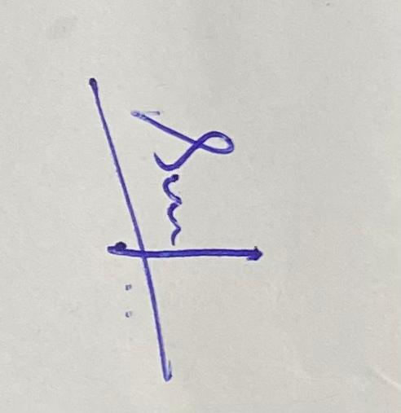

3. DESCRIPTION OF THE INVENTION:
- PROBLEM ADDRESSED BY THE INVENTION:
In most of the house in Rural areas of India has no proper medical facilities. Because of this the people on Rural areas are not so aware of their health. Because of this most of the people in Rural areas facing so many health issues.

- OBJECTIVE OF THE INVENTION
- To create a compact, lightweight, and easy-to-use device capable of acquiring ECG signals for real-time cardiac monitoring. To store measured ECG signals and heart rate values for future analysis, diagnosis, or medical reference.
- To design an interface (LCD/Display) that clearly presents ECG waveform and heart rate data for easy understanding. To help patients and healthcare providers monitor heart health outside hospitals or clinical settings.
- STATE OF THE ART/ RESEARCH GAP/NOVELTY: Existing technologies for calculating Heart Rate Logger are very expensive and very bulky in size.
Sr. No. | Patent ID | Abstract | Research Gap | Novelty
 | US6102856B1 | Describes a wearable ECG monitoring system capable of capturing heart signals and transmitting data wirelessly to cloud-based platforms for analysis. The system focuses on continuous remote cardiac monitoring using IoT infrastructure. | Heavy dependence on internet connectivity and cloud services makes it unsuitable for rural and low-infrastructure areas. High cost and complex setup limit accessibility. | The proposed system works fully offline, uses local data logging via SD card, and is low-cost and portable, making it ideal for rural healthcare without internet dependency.
 | IN201721024689A | Presents a portable ECG acquisition device using biomedical sensors and microcontroller-based processing for hospital and home use. Emphasis is on real-time ECG visualization. | Lacks long-term data storage and timestamping. Limited focus on affordability and battery-powered rural deployment. | The proposed project integrates ECG and heart rate logging, RTC-based time stamping, and battery-powered operation, ensuring continuous monitoring and historical data analysis at very low cost.
 | US20190327844A1 | A compact ECG and vital sign monitoring device designed primarily for clinical environments with high-accuracy signal processing and professional medical interfaces. | Designed mainly for hospital use; expensive hardware and trained personnel are required. Not suitable for use by non-specialists in rural settings. | The proposed system is simple, user-friendly, and designed for primary healthcare use, allowing basic cardiac diagnostics without specialized training or clinical infrastructure.
 | US6587712B1 | Describes a portable electrocardiogram monitoring device intended for intermittent ECG recording outside traditional hospital environments for later medical evaluation. | Does not support continuous ECG monitoring, real-time waveform display, or integrated long-term data logging with timestamps. | The proposed project supports continuous real-time ECG monitoring, live waveform display, and SD card–based long-term data storage with RTC time stamping.
 | US5333616A | Presents a wrist-worn ECG monitoring device that records cardiac electrical activity using built-in electrodes and transmits data to external systems for diagnostic purposes. | Depends on wearable-specific hardware and external communication systems. Limited offline storage and higher cost reduce suitability for low-resource areas. | The proposed system is a standalone, low-cost ECG and heart rate logger that operates fully offline and is suitable for rural and emergency healthcare applications.
 | US20180133079A1 | Describes a portable cardiac monitoring system capable of acquiring ECG signals and transmitting them wirelessly to smartphones for analysis and storage. | Dependence on smartphones and wireless connectivity limits usability in areas without smart devices or stable networks. | The proposed project operates independently without smartphones or internet, offering offline ECG and heart rate monitoring with onboard display and SD card logging.
 | IN201811045678A | Presents a compact ECG monitoring device for personal healthcare applications with real-time signal acquisition and embedded display systems. | Lacks long-term ECG data logging, time-stamping, and optimized low-power operation for extended use. | The proposed system supports real-time display along with long-term ECG logging using SD card and RTC, enabling continuous monitoring and historical analysis.
 | US20170246052A1 | A wearable ECG monitoring apparatus designed to continuously record heart activity and transmit data for clinical diagnostics. | Wearable design increases cost and complexity and relies on external communication infrastructure. | The proposed project is a non-wearable, low-cost, standalone ECG and heart rate logger optimized for affordability and rural healthcare use.
 | US20140155909A1 | Describes a multi-parameter health monitoring device capable of recording ECG along with other physiological parameters using advanced processing techniques. | Multi-parameter integration increases system complexity, power consumption, and cost. | The proposed system focuses specifically on ECG and heart rate monitoring, reducing complexity while ensuring reliable operation in low-resource environments.
10 | US8954129B1  US6587712B1 | Describes a portable ECG monitoring device designed for recording cardiac signals during specific events for later analysis. | Does not include continuous monitoring, real-time visualization, or long-term timestamped storage. | The proposed system provides continuous ECG monitoring, real-time waveform display, and SD card–based data logging with RTC time stamping

DETAILED DESCRIPTION:
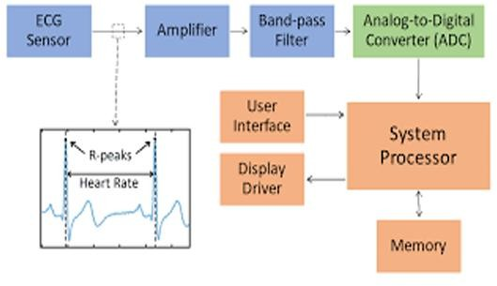
Fig. 1: Flow diagram
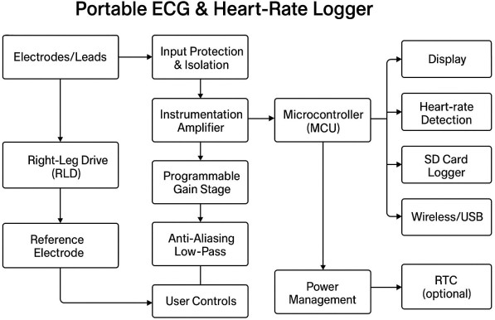
Fig. 2: Block Diagram

- Components and their Purpose
- Microcontroller: An Arduino Nano or a similar compact development board, powered via a mini-USB connection. It acts as the central processing unit for the system. Optical Dust Sensor: Detects the dust that is suspended due to the movement of the brush. This helps the system to decide if cleaning is necessary or not.
- OLED Display: A small, square OLED screen is connected, likely an SSD1306 model, used for displaying data or status information in monochrome.
- SD Card Module: A blue module with a microSD card slot is present at the top. This component is used for data logging, allowing the system to store collected data over time.
- AD8232 ECG SENSOR: Measure electrical heart activity filters and amplifies biopotential signals
- ADS1115: Converts analog signals to digital signals
- bit 4 channels
- POWER SUPPLY MODULE: Transmit and regulars power supply of 3.3 to 5V
- ECG ELECTRODES: TRANSMITS ANOLOG SIGNALS to AD8232 which further translates them to digital signals
- User Interface: Allows the initiation of manual cleaning through a single click.

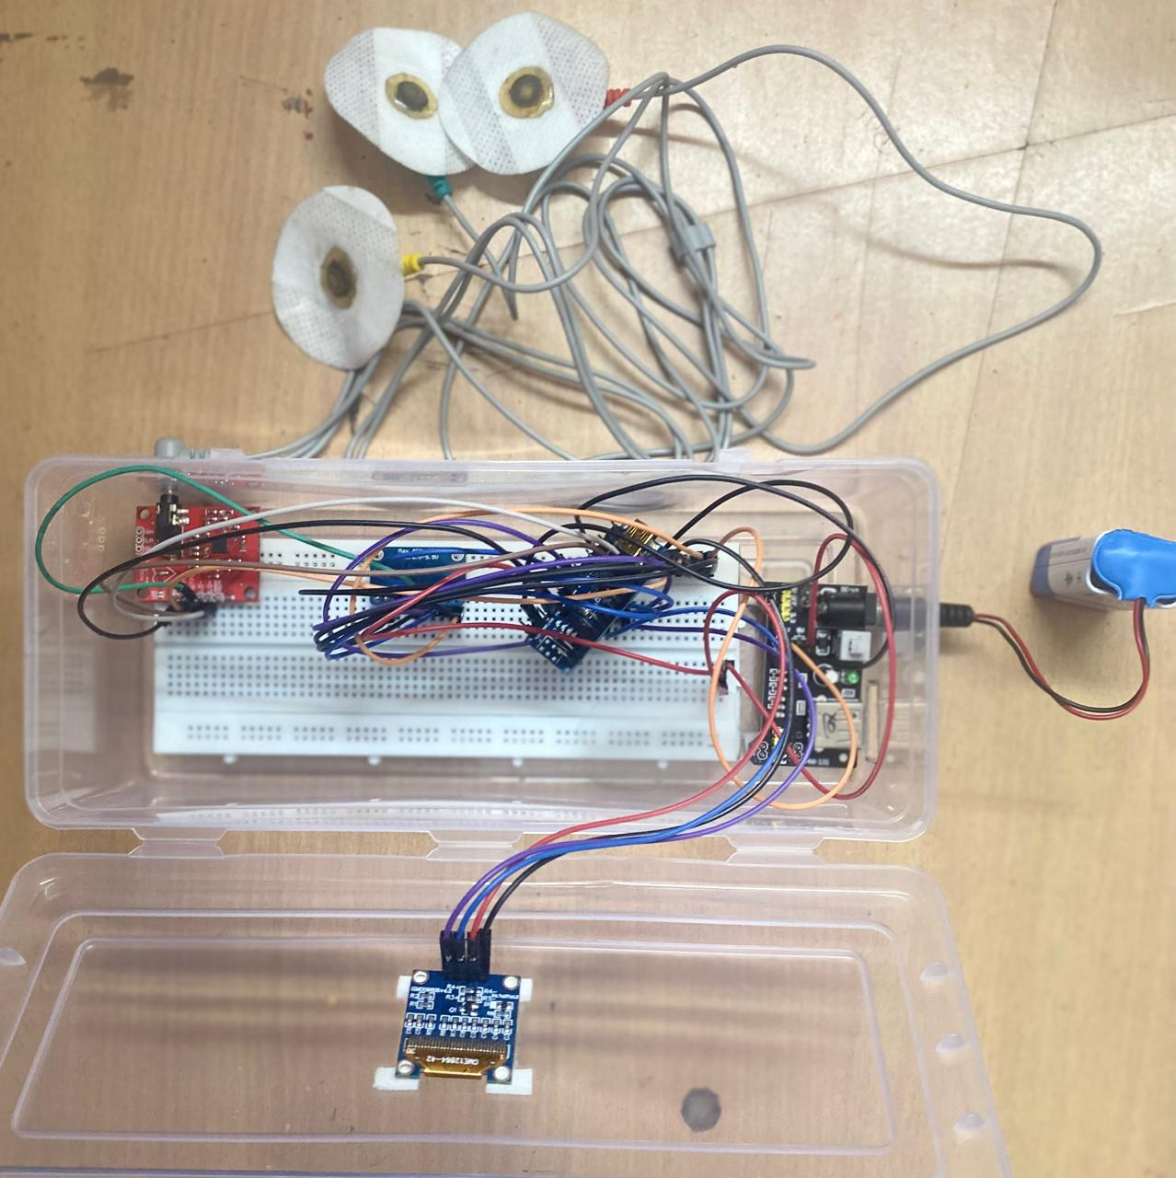

Fig 3 Working Circuit portable ECG and heart rate logger
E. (i) RESULTS:
- The results and discussion section presents the performance outcomes of the Portable ECG and Heart Rate Logger after design, implementation, and testing. It evaluates the device’s accuracy, signal quality, reliability, power consumption, and real-time functionality. The discussion also interprets challenges, limitations, and improvements based on observed measurements.
- 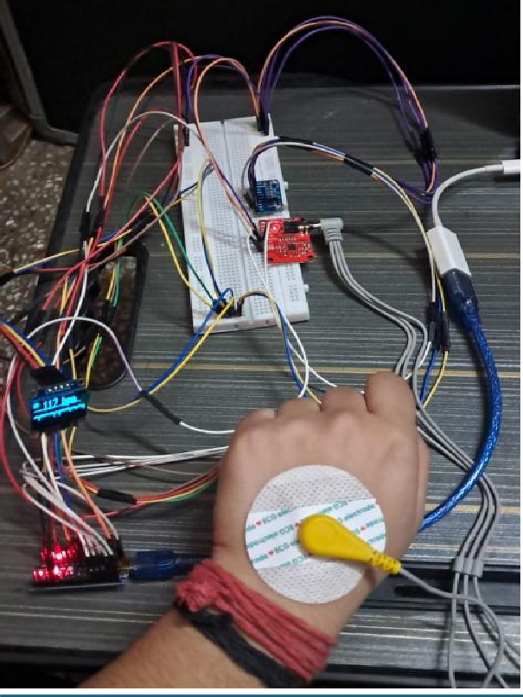

Fig. 4: working model portable ECG and heart rate
- A portable ECG and heart rate logger works by using electrodes to capture the heart's weak electrical signals from the skin, which are then amplified, filtered, digitized, and processed by a microcontroller. The processed data is either displayed locally, transmitted wirelessly to a smartphone/PC, or stored on local memory for later analysis. Fig.no 4

(ii) ADVANTAGES:
Key Advantages:
Cost-Effectiveness: Using an Arduino Nano and an AD8232 sensor module significantly reduces the cost of building an ECG device, making it an accessible solution for personal health tracking and in low-resource settings.
High Portability and Compactness: The Arduino Nano is very small and lightweight, allowing the device to be easily worn or carried in a pocket
Real-time Monitoring & Data Logging: The system can monitor ECG signals in real-time and, with an added SD card module, record data for later analysis.
Customization and Flexibility: As an open-source platform, the Arduino Nano allows developers to tailor the software to detect specific cardiac conditions
Educational Potential: This project offers a practical, hands-on experience in biomedical engineering, specifically in understanding bio-potential signal acquisition, filtering, and analysis
Easy Data Integration: The system can easily be connected to other modules, such as Bluetooth (HC-05/06) or Wi-Fi (ESP8266), to transmit live data to a smartphone or cloud server for remote health monitoring (telemedicine).
F. EXPANSION:
NOT Applicable
G. WORKING PROTOTYPE/ FORMULATION/ DESIGN/COMPOSITION:
Circuit Diagram:
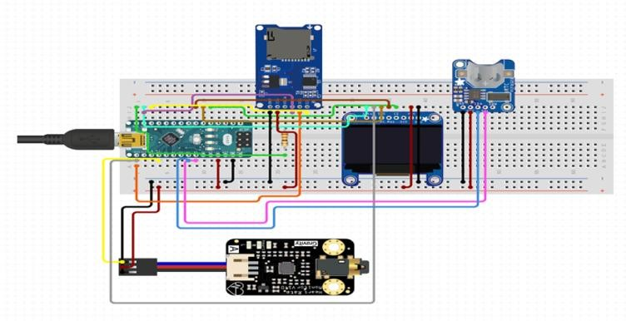
Fig. 6: Simulation Circuit Diagram of the portable ECG and heart rate logger
Composition:
The image displays an electronic circuit assembled on a breadboard, likely a prototype for a data logging or health monitoring system. The primary components are an Arduino- compatible microcontroller, an OLED display, an SD card module, a sensor, and a power point.
Components Analysis
- Microcontroller Board: The green board on the left appears to be an Arduino Nano or a similar compact development board, powered via a mini-USB connection. It acts as the central processing unit for the system.
- OLED Display: A small, square OLED screen is connected, likely an SSD1306 model, used for displaying data or status information in monochrome.
- SD Card Module: A blue module with a microSD card slot is present at the top. This component is used for data logging, allowing the system to store collected data over time.
- Sensor Board: A black board labeled "Gravity" at the bottom is connected to the microcontroller. Based on similar projects, this is likely a sensor, possibly a pulse oximeter (MAX30100) or another environmental sensor, used to gather input data.
- Connectivity Board: A small blue board on the right with a circular opening might be related to power management or another specific sensor input, though its exact function is less clear from the image alone.

4. USE AND DISCLOSURE (IMPORTANT):
- Have you described or shown your invention/ design to anyone or in any conference? | YES (⬉ ) | NO ( )
- Have you made any attempts to commercialize your invention (for example, have you approached any companies about purchasing or manufacturing your invention)? | YES ( ) | NO (⬉)
- Has your invention been described in any printed publication, or any other form of media, such as the Internet? | YES ( ) | NO (⬉)
- Do you have any collaboration with any other institute or organization on the same? Provide name and other details. | YES ( ) | NO (⬉)
- Name of Regulatory body or any other approvals if required. | YES ( ) | NO (⬉)

5. Provide links and dates for such actions if the information has been made public (Google, research papers, YouTube videos, etc.) before sharing with us.
Not applicable
6. Provide the terms and conditions of the MOU also if the work is done in collaboration within or outside university (Any Industry, other Universities, or any other entity).
Not Applicable
7. Potential Chances of Commercialization.
High, as this project is a novel patentable idea with applications in residential and commercial window maintenance. The integration of Arduino-based automation makes it cost-effective and scalable for mass production. Future iterations can include AI-based cleaning mechanisms and IoT connectivity to enhance market appeal.
8. List companies that can be contacted for commercialization along with the website link.
- BMTF (Bangalore Mechatronics Pvt. Ltd.) (http://www.bangaloremechatronics.in/)
- Kieback&Peter India (https://www.kieback-peter.com/en/)
- Tormax India (https://www.tormax.com/)
9. Any basic patent that has been used and we need to pay a royalty to them.
Not applicable

10. FILING OPTIONS: Please indicate the level of your work that can be considered for provisional/ complete/ PCT filings.
PROVISIONAL

11. KEYWORDS: Portable ECG, Heart Rate Monitoring, ECG Signal Acquisition, Biomedical Instrumentation, Wearable Health Device, Real-Time Monitoring, Microcontroller.
Signature of Inventor | Name of Inventor with UID and Department | Date

